NCATS HUMAN SUBJECTS RESEARCH PRIOR APPROVAL (HSRPA)
ADDENDUM & INSTRUCTIONS

December 9, 2019 Revision

All NCATS Prior Approval requests must include completed Addendum (Sections A. I & II) and all specified documents. The Addendum and specified documents must be submitted by the Institutional Signing Official (SO) via eRA HSS. The information entered below will complement the information entered into the eRA HSS module and assist in the NCATS’ review of the request.

- ADDENDUM

SECTION I. Complete each field.

Name of Pilot Study Principal Investigator (PI) or KL2-Scholar (Designated Study PI) | Click here to enter text.
Type of Proposed Research & Duration of Requested Support | ☐ Pilot Study ☐ KL2 Project ___Yrs ___Mo
Name of KL2-Scholar Mentor (if appropriate) | Click here to enter text.
Acknowledgement that Mentor/ Supervisor has reviewed and approves the submitted project | ☐ Yes
Study Type (as designated by institution and/or IRB) | ☐ Exempt  Exemption # ☐1 ☐2 ☐3 ☐4 ☐5 ☐6 ☐7 ☐8  ☐ No More Than Minimal Risk  ☐ Greater Than Minimal Risk  ☐ Clinical Trial
Population(s) (Check all that apply) | ☐ Adults ☐ Children (≤18 yrs old)
Title* of Proposed Research Protocol  *This must match the title  on the IRB-Approval documentation | Click here to enter text.
Title and PI of Parent Study (if proposed research is ancillary to another study) | Click here to enter text.
Is this study collecting genomic data? See: NIH Genomic Data Sharing | ☐ Yes ☐ No
CTSA Institution | Click here to enter text.
CTSA Grant Number | Click here to enter text.
NCATS Program Director/Program Officer (PD/PO) | Click here to enter text.
NCATS Grants Management Specialist (GMS) | Click here to enter text.
Institutional Signing Official (SO) | Click here to enter text.

SECTION II
- Complete #1, #2, & #3 for all requests. Complete #4 for all requests except those that meet the criteria for any Exemption under 45 CFR 46. (This revision separates summary and budget information request)
- Provide a brief (< 500 words) summary of the specific aspects of the proposed study that will be supported by NCATS funds.
Click here to enter text.

- List a line item budget for each specific aspect to be supported with NCATS funds (list supplies, services, and personnel costs; per NIH policy, generally only expenses greater than $1,000 require an itemized breakdown). Please note: KL2 scholar salaries should not be included in the budget.
Click here to enter text.

- If the proposed research is considered an amendment or is a sub-study/ancillary study to an IRB-approved parent protocol, provide a summary of the parent protocol with an explanation of how the proposed study connects to it.
Click here to enter text.

- NIH Biosketches are required for the Study PI and for each Key Personnel involved in the proposed human subjects research study (except for studies that meet any Exemption under 45 CFR 46). List names of Key Personnel involved in the study and state whether their Biosketch is included in the CTSA grant application. For biosketches not included in the CTSA grant application, see Section III below.
Click here to enter text.

- INSTRUCTIONS
SECTION I. NOTES
  - Beginning January 1, 2019, the “NCATS Prior Approval of Delayed Onset (DO) Research Involving Human Subjects” process was renamed the “NCATS Human Subjects Research Prior Approval (HSRPA).” Below are updates, instructions, and background information related to the NCATS’ submission and review processes for NCATS HSRPA requests.
  - Due to new NIH policy, Human Subjects Research Prior Approval (HSRPA) requests will now be submitted via the eRA Human Subjects System (HSS).
    - The current HSS functions as a document repository, so communications between the submitter and NCATS Program and Grants Management staff will be via email.
    - The HSS, ASSIST, and Forms-E User Guides are very useful.
    - Institutions may need to develop an internal system for entry of New Studies if the Study PI does not have access to the system.
    - Awardees will not be able to add new studies to the HSS if a grant indicates “NO” for human subjects research; contact your Program Director if the human subjects research code needs to be changed. Inclusion should be “yes” on UL1s and should be “no” on KL2s and TL1s. If a human subjects research code or Inclusion Monitoring status needs to be changed, please contact your NCATS Program Director/Program Officer, who will guide you through the process.
  - This revised Addendum (December 9, 2019 version 4.0) for NCATS HSRPA requests will assist submitters in determining the appropriate documents that must be submitted for human subjects research (HSR). This version must be used for requests submitted on or after March 9, 2020.
  - All NCATS HSRPA requests for a New Study MUST be IRB approved prior to submission and IRB-Approval documentation MUST be included with the request. This may require an investigator to “de-link” an initial non-HSR portion of a study from the HSR portion: complete the non-HSR portion, obtain IRB approval for the HSR portion, and submit the HSRPA once IRB approval has been obtained.
  - To reduce submission burden, we have classified HSRPA requests and specify requirements for each.
- Human Subjects Research that meets the NIH definition of a clinical trial
- Human Subjects Research that does not meet the NIH definition of a clinical trial (4 sub-categories):
B1: Study deemed Greater than Minimal Risk by IRB OR the risk determination is not indicated in the IRB approval documentation OR involves pregnant women, human fetuses or neonates, prisoners, children, or individuals with impaired decision-making capacity
B2: Study deemed No More than Minimal Risk by the IRB and does not populations under B1.
B3: Study meeting the criteria for Exemptions 1-3 or 5-8 under 45 CFR 46
B4: Study meeting the criteria for Exemption 4 under 45 CFR 46

SECTION II. DOCUMENT PREPARATION FOR SUBMISSION
- Formatting
1. Include footers on individual PDF documents to identify (IRB-approval, biosketches, etc.)
2. HSS only accepts PDFs. Convert each required document into a PDF and then combine into a single PDF file in the order shown in Table 1. Do not scan to convert to PDF, as the quality will degrade.
3. Name your combined PDF file as follows: HSRPA _CTSA Institution_ Study PI Last Name_Date

SECTION III. SUMMARY of NCATS-REQUIRED DOCUMENTS & HSS SECTIONS to be COMPLETED

 | Clinical Trial | Non-Clinical Trial
STUDY CATEGORY | A¹ | B1² | B2³ | B3⁴ | B4⁵
COMPLETE HSS SECTIONS  (see below for details) | 1-5 | 1, 2, 3.1 & 3.2 | 1, 2, 3.1 & 3.2 | 1, 2, 3.1⁶  & 3.2 | 1, 3.1⁶ & 3.2
NCATS-Required Documents
Addendum | √ | √ | √ | √ | √
Certification of IRB-Approval | √ | √ | √
Institutional Exemption Determination |  |  |  | √ | √
Relevant biosketches not contained in the CTSA grant appl. | √ | √ | √
Institutional letter attesting to completion of Human Subjects Training for PI and key personnel⁷ | √ | √ | √ | √ | √
IRB-Approved Protocol | √ | √
IRB-Approved informed consent, verbal consent transcript, assent and parental permission documents, or documentation of IRB waiver (as applicable) | √ | √
Specified NCATS Required Document PDFs should be combined and attached in HSS Sections | 5.1 | 2.7  (Study Timeline attachment box must be used to attach the Study Timeline plus the NCATS-specified documents.) |  | 3.1⁶  (Protections of Human Subjects attachment box must be used to attach justification for exemption statement.)
¹A: Human Subjects Research that meets the NIH definition of a clinical trial. Answered “Yes” to all the questions in HSS Section 1.4 - Clinical Trial Questionnaire.
²B1: Study deemed Greater than Minimal Risk by IRB OR the risk determination is not indicated in the IRB approval documentation OR involves pregnant women, human fetuses or neonates, prisoners, children, or individuals with impaired decision-making capacity
³B2: Study deemed No More than Minimal Risk by the IRB and does not involve pregnant women, human fetuses or neonates, prisoners, children, or individuals with impaired decision-making capacity
⁴B3: Study meeting the criteria for Exemptions 1-3 or 5-8 under 45 CFR 46
⁵B4: Study meeting the criteria for Exemption 4 under 45 CFR 46
⁶Section 3.1: If you are claiming that your human subjects research falls under any exemptions, a full Protection of Human Subjects section that addresses topics 1-4 (Forms-E Instructions pages G. – 261-264) is not required. Instead, attach a document here that justifies why the research meets the criteria for the exemption(s) that you have claimed; explain how the proposed research meets the criteria for the exemption claimed.
⁷Institutional letter attesting to completion of Human Subjects Training for PI and key personnel: NIH policy (NOT-OD-00-039 & NOT-OD-01-061) requires education on the protection of human research participants for PI and all key personnel; insert signed letter.

 | (see footnotes on page 6) |  | Clinical Trial |  | Non-Clinical Trial
 | STUDY CATEGORY |  | A¹ |  | B1² | B2³ |  | B3⁴ |  | B4⁵
eRA HUMAN SUBJECTS SYSTEM REQUIREMENTS
HSS Section 1 – Basic Information
1.1 |  | Study Title | √ | √ |  | √ | √ |  | √
1.2 |  | Is this Study Exempt from Federal Regulations? | √ | √ |  | √ | √ |  | √
1.3 |  | Exemption Number | √ | √ |  | √ | √ |  | √
1.4 |  | Clinical Trial Questionnaire | √ | √ |  | √ | √ |  | √
HSS Section 2 – Study Population Characteristics
2.1 |  | Conditions or Focus of Study | √ | √ |  | √ | √
2.2 |  | Eligibility Criteria | √ | √ |  | √ | √
2.3 |  | Age Limits | √ | √ |  | √ | √
2.4 |  | Inclusion of Women, Minorities and Children | √ | √ |  | √ | √
2.5 |  | Recruitment and Retention Plan | √ | √ |  | √ | √
2.6 |  | Recruitment Status | √ | √ |  | √ | √
2.7 |  | Study Timeline | √ | √ |  | √ | √
2.8 |  | >Enrollment of First Subject &  >Inclusion Enrollment Report(s) | √⁸ | √⁸ |  | √⁸ | √⁸
HSS Section 3 – Protection and Monitoring Plans
3.1 |  | Protection of Human Subjects | √ | √ |  | √ | √⁶ |  | √⁶
3.2 |  | Is this a multi-site study? | √⁹ | √⁹ |  | √⁹ | √⁹ |  | √⁹
3.3 |  | Data and Safety Monitoring Plan | √ | Optional |  | Optional
3.4 |  | Data and Safety Monitoring Board? | √ | Optional |  | Optional
3.5 |  | Overall Structure of the Study Team | √ | Optional |  | Optional
HSS Section 4 – Protocol Synopsis
4.1 |  | Brief Summary | √
4.2.a |  | Narrative Study Description | √
4.2.b |  | Primary Purpose | √
4.2.c |  | Interventions | √
4.2.d |  | Study Phase | √
4.2.e |  | Intervention Model | √
4.2.f |  | Masking | √
4.2.g |  | Allocation | √
4.3 |  | Outcome Measures | √
4.4 |  | Statistical Power and Design | √
4.5 |  | Subject Participation Duration | √
4.6 |  | FDA-Regulated Intervention? (IND/IDE) | √
4.7 |  | Dissemination Plan | √
HSS Section 5 – Other Clinical Trial Attachments
5.1 |  | Other Clinical Trial Attachments | √

¹A: Human Subjects Research that meets the NIH definition of a clinical trial. Answered “Yes” to all the questions in HSS Section 1.4 - Clinical Trial Questionnaire.
²B1: Study deemed Greater than Minimal Risk by IRB OR the risk determination is not indicated in the IRB approval documentation OR involves pregnant women, human fetuses or neonates, prisoners, children, or individuals with impaired decision-making capacity
³B2: Study deemed No More than Minimal Risk by the IRB and does not involve pregnant women, human fetuses or neonates, prisoners, children, or individuals with impaired decision-making capacity
⁴B3: Study meeting the criteria for Exemptions 1-3 or 5-8 under 45 CFR 46
⁵B4: Study meeting the criteria for Exemption 4 under 45 CFR 46
⁶Section 3.1: If you are claiming that your human subjects research falls under any exemptions, a full Protection of Human Subjects section that addresses topics 1-4 (Forms-E Instructions pages G. – 261-264) is not required. Instead, attach a document here that justifies why the research meets the criteria for the exemption(s) that you have claimed; explain how the proposed research meets the criteria for the exemption claimed.
⁷Institutional letter attesting to completion of Human Subjects Training for PI and key personnel: NIH policy (NOT-OD-00-039 & NOT-OD-01-061) requires education on the protection of human research participants for all key personnel submitting NIH applications for grants or proposals for contracts or receiving new or non-competing awards for projects involving human research participants and a letter signed by the official authorized to represent the institution that documents completion of the education. The letter must describe education completed in the protection of human subjects for the Study PI and each individual identified as “key personnel” in the proposed research. Insert the signed letter.
⁸Section 2.8 & Inclusion Enrollment:
Inclusion Enrollment: Existing Datasets or Resources: KL2 does not report inclusion; UL1: If you will use an existing dataset, resource, or samples that may have been collected as part of a different study, you must address inclusion. Generally, you must provide details about the sex/gender, race, and ethnicity of the existing dataset/resource and justify the details as appropriate to the scientific goals of the proposed study.
For more information about what is considered an existing dataset or resource for inclusion policy, see the NIH FAQs on Monitoring Inclusion When Working with Existing Datasets and/or Resources.
⁹Section 3.2 Multi-site Studies: Answer "Yes/No;" or select N/A only if: a. You answered “Yes” to “Question 1.2 Is this Study Exempt from Federal Regulations?” or b. You are a career development applicant; or c. You are a training applicant; or d. You are a fellowship applicant (sIRB policy does not apply to situations b, c, and d.). If you answer "YES" - Multi-site studies using the same protocol: Attach Plan describing how you will comply with the NIH policy on the use of single-IRB for multi-site research.

SECTION IV. SUBMISSION PROCESS
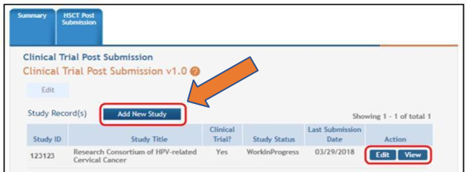
  - Once in the HSS module, PIs/SOs enter all study-related information after clicking on the “Add New Study” button.
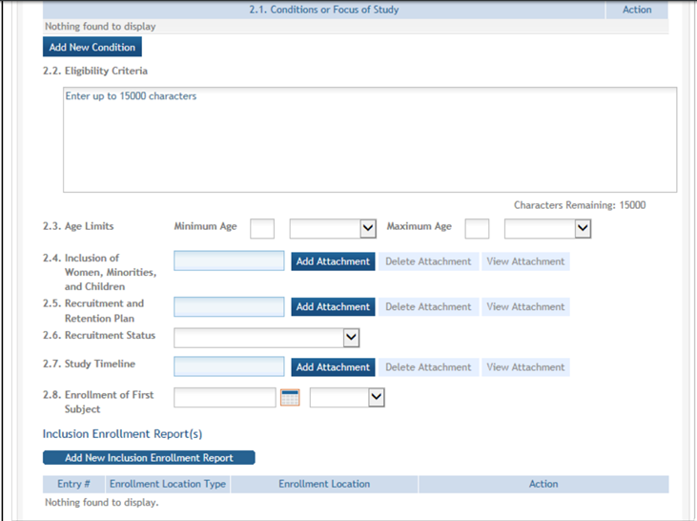
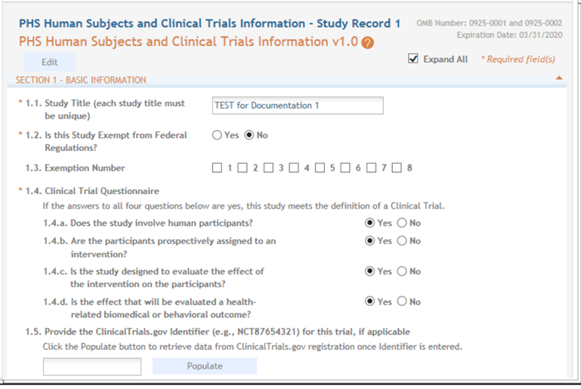
  - Complete fields and attach HSS- and NCATS-specified documents in HSS; Screen Shots:
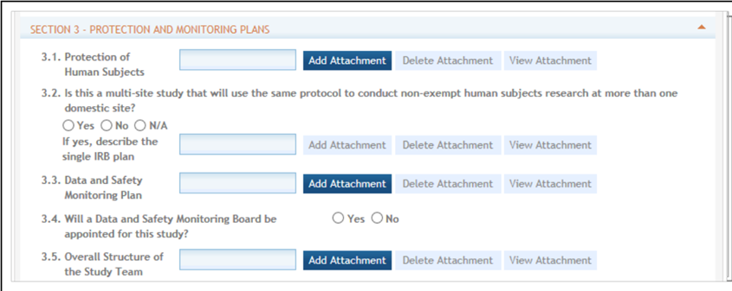

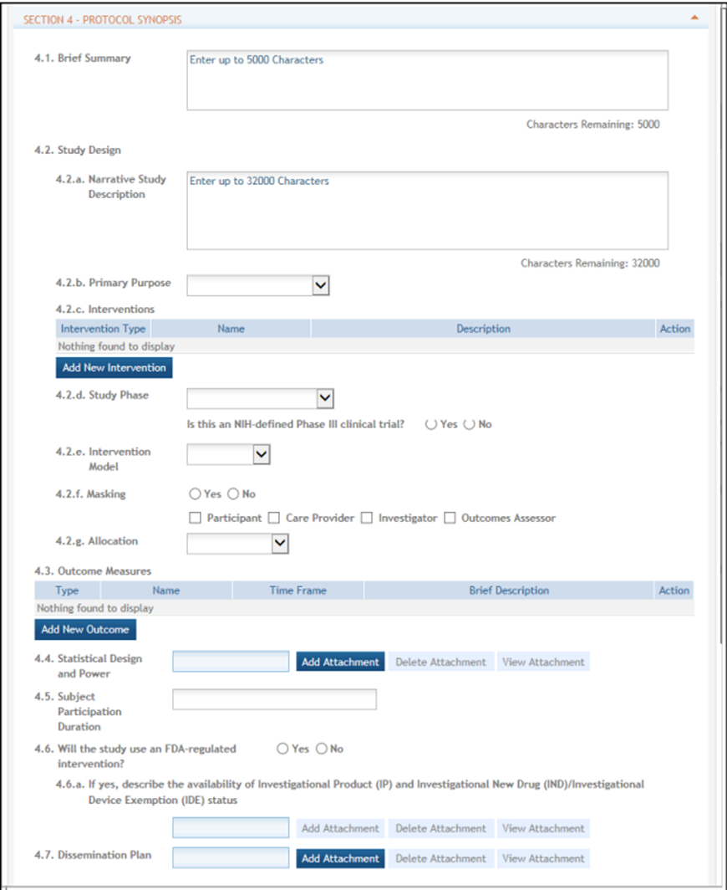

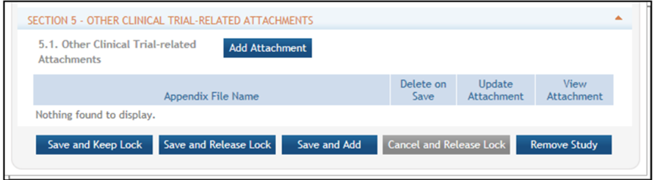

- Once the study is saved, it will be added to the Study Record table
- Multiple steps must be completed for submission of a New Study; please ensure that all steps have been taken.
  - Save & Lock/Save & Release Lock: PI or SO
  - Ready for Submission: PI or SO
  - Submit: SO only
- After the SO submits the study record, NCATS will receive notification of this action (We have noted instances when the Program Officer does not receive an automated eRA notification of the submission of a New Study, so please follow-up with an email to your assigned Program Officer and Grants Management Specialist.)
- After submission of a study by the SO, the study status must be changed manually to “Work In Progress.”
This will allow another New Study to be added.

SECTION V. REVIEW PROCESS & RESPONDING TO REQUESTS FOR CLARIFICATION OR ADDITIONAL INFORMATION
  - NCATS GM and PO will review Prior Approval requests primarily for risks to human subjects, inclusion, scientific merit, feasibility, and budget.
  - NCATS GM will initiate review of the request and notify (via email) the PI/SO of the outcome within 30 calendar days.
  - NCATS GM may request clarification or revisions via email to the SO. SOs should: 1. Submit any clarifications/revisions into the eRA HSS module, and 2. Send an email response to NCATS that includes a Summary Change Table that indicates all submitted changes/amendments (i.e., what the changes are and where they are located). This will facilitate expedited reviews and decisions by NCATS.
  - Please note that if a request is returned for any reason, the 30-day turnaround time resets.

SECTION VI. BACKGROUND INFORMATION

Human Subjects System
NIH developed the Human Subjects System (HSS), which consolidates human subjects and clinical trial information in one place, as part of its larger effort to comply with 21st Century Cures requirements to enhance accountability and transparency in NIH clinical research. HSS is a shared system, used both by principal investigators and signing officials on one hand and by NIH staff on the other. The system was launched in June 2018 and replaced the Inclusion Management System (IMS) used for reporting participant sex/gender, race, and ethnicity information. HSS is accessed via the Human Subjects link in eRA Commons (via the Status tab or the RPPR tab). The Human Subjects link will only be visible if the application/grant is marked “yes” for human subjects research.
- Award Recipient Features in HSS
  - Pre-award (post review) for just-in-time information or correction of human subjects data
  - Post-award to add/update human subjects study information; create new inclusion enrollment reports; or view/edit/update existing enrollment data when submitting a Research Performance Progress Report (RPPR)
    - Convert a delayed onset study to a full study record, once detailed study information is available
    - Add a New Study (For NCATS awards: already IRB-approved and all required documents are available)
    - Add a New Delayed Onset Study (must provide justification for why details of the study will not be available until later)
  - Off-cycle updates as required in the Funding Opportunity Announcement or terms and conditions of award, e.g., to add a New Study for Prior Approval
  - Provide interim data as requested by NIH staff
  - Inform NIH of ClinicalTrials.gov registration

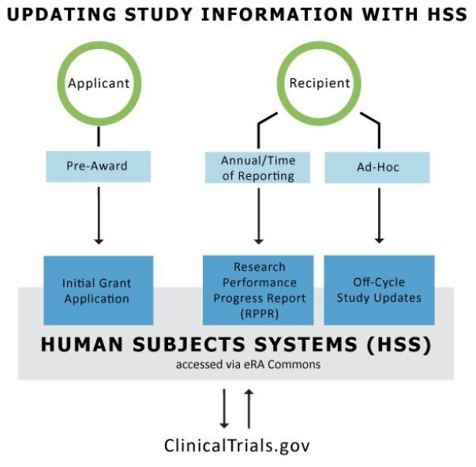
Important Note: The Human Subjects and Clinical Trials Information form appears for all recipients with human subjects studies. However, those who submitted competing applications prior to January 25, 2018 only need to update inclusion data via the Human Subjects link in the RPPR. The remaining fields (e.g., milestones) are not required to be filled out.
Those who submitted applications on or after January 25, 2018, may need to fill out more fields than the inclusion data for their RPPR.

SECTION VII. DEFINITIONS
- NIH Definition of Clinical Research: Research with human subjects that is: 1) Patient-oriented research. Research conducted with human subjects (or on material of human origin such as tissues, specimens, and cognitive phenomena) for which an investigator (or colleague) directly interacts with human subjects. Excluded from this definition are in vitro studies that utilize human tissues that cannot be linked to a living individual. It includes: (a) mechanisms of human disease, (b), therapeutic interventions, (c) clinical trials, or (d) development of new technologies. 2) Epidemiological and behavioral studies. 3) Outcomes research and health services research.
- NIH Definition of Clinical Trial: A research study in which one or more human subjects are prospectively assigned to one or more interventions (which may include placebo or other control) to evaluate the effects of those interventions on health-related biomedical or behavioral outcomes.
- NIH Definition of Human Subjects Research: According to 45 CFR 46 Link to Non-U.S. Government Site - Click for Disclaimer, a human subject is "a living individual about whom an investigator (whether professional or student) conducting research:
- Obtains information or biospecimens through intervention or interaction with the individual, and uses, studies, or analyzes the information or biospecimens; or
- Obtains, uses, studies, analyzes, or generates identifiable private information or identifiable biospecimens.
  - New Study means that a study was not included in the grant application; studies are identified and added after award. You include none of the required supporting material with the application. A new human subjects project must be entered into the HSS as a NEW STUDY and will require Prior Approval from your NCATS Program Director and Grants Management Official. NOTE: NCATS requires that IRB approval be obtained prior to entry into the HSS.
  - NCATS Prior Approval for Human Subjects Research: Consistent with the HHS regulations (45 CFR 46.120) and NIH policies on human subjects protections(link is external), NCATS awardees must seek approval from NCATS to conduct research involving human subjects that was not described in the original, peer-reviewed grant application; this applies to all pilot studies and KL2-scholar projects involving human subjects supported by NCATS, including full funding support, partial funding support or voluntary committed cost share.

SECTION VIII. RESOURCES
  - https://humansubjects.nih.gov/
  - https://www.ecfr.gov/cgi- bin/retrieveECFR?gp=&SID=83cd09e1c0f5c6937cd9d7513160fc3f&pitd=20180719&n=pt45.1.46&r=PAR T&ty=HTML#se45.1.46_1104
  - https://era.nih.gov/hss_training.htm
  - https://era.nih.gov/files/HSS_user_guide.pdf
  - https://era.nih.gov/files/assist_user_guide.pdf
  - https://grants.nih.gov/grants/how-to-apply-application-guide/format-and-write/format- attachments.htm (required format of attachments)
  - https://ncats.nih.gov/ctsa/funding/prior-approval-faq
  - https://grants.nih.gov/policy/clinical-trials/human-subjects-system.htm
  - https://humansubjects.nih.gov/sites/hs/pdf/HS-Scenarios-for-Forms-E.pdf
  - https://ncats.nih.gov/ctsa/funding/prior-approval-faq#clarification
  - https://grants.nih.gov/grants/funding/inclusion-basis-on-sex-gender-race-ethnicity-faq.htm#5510
  - https://grants.nih.gov/grants/funding/women_min/inclusion_training.htm
  - https://grants.nih.gov/grants/how-to-apply-application-guide/forms-e/general-forms-e.pdf
  - https://grants.nih.gov/grants/how-to-apply-application-guide/forms-e/multi-project-forms-e.pdf
  - https://ctsa.ncats.nih.gov/governance-guidelines/guidelines/prior-approval-of-planned-research-involving-human-subjects/
  - https://ncats.nih.gov/ctsa/funding/prior-approval-paga

For assistance with this Addendum or requested content, please contact NCATSDOPAinquiry@mail.nih.gov

For assistance with the eRA HSS, please contact the eRA Service Desk https://grants.nih.gov/support/index.html
Toll-free: 1-866-504-9552 (Press 1 for eRA Commons or ASSIST)
Phone: 301-402-7469 (Press 1 for eRA Commons or ASSIST)
Hours: Mon-Fri, 7 a.m. to 8 p.m. ET (closed on federal holidays)

