NCATS NEW PROJECTS WITH HUMAN SUBJECTS RESEARCH
ADDENDUM & INSTRUCTIONS

May 07, 2021 updated document:

INTRODUCTION
Effective April 28,2021, the NCATS process for Clinical and Translational Science Awards (CTSA) Program UL1 Pilot Projects and KL2 projects that involve human subjects research (HSR) and are supported with direct CTSA grant funding and/or voluntary committed cost share has changed (see Notice here). This change applies to CTSA UL1 Pilot Program Projects, including UL1 Pilot Projects for which the designated study Principal Investigator is a KL2 Scholar and to KL2 projects.
Briefly, CTSA institutions will no longer need to wait for NCATS approval for new domestic UL1 CTSA Program Pilot Projects and KL2 Scholar projects involving human subjects. In addition CTSA institutions will need to submit fewer documents for studies that are determined by the IRB or recipient institution to be non-NIH-defined Clinical Trials, minimal risk, or exempt from regulatory requirements (45 CFR 46). Entry of these studies into the eRA Human Subjects System (HSS) along with NCATS-specified documentation and email notification of NCATS (NCATSPriorApprovalRequest@mail.nih.gov) address with a copy to the assigned PO and GM Specialist are required before the project can begin. The described changes will reduce award recipient burden in the administration of clinical and translational science pilot projects and will accelerate the clinical and translational research project process.

The following types of studies continue to require entry of the study into the eRA HSS and official notification from NCATS of NCATS’ Prior Approval before the project can begin: new UL1 CTSA Program Pilot Projects and KL2 Scholar projects that include human subjects research determined by the Institutional Review Board (IRB) to be Greater Than Minimal Risk, meet the criteria for an NIH-defined Clinical Trial, or include a foreign component.

The information provided by the investigator and attested to by the Institutional Signing Official (SO) in the required Addendum (A. Sections I & II) below, as well as required documents, will complement the information entered into the eRA HSS module and assist in the NCATS’ review of the request.

DEFINITIONS & PROCESS SUMMARY
For the purpose of this guidance, human subjects research (HSR) categories are defined as follows:
- Category 1: Greater Than Minimal Risk studies, NIH-defined Clinical Trials and/or studies that contain a foreign component
  - Category 1 studies/trials require Prior Approval. Note: NIH-defined Clinical Trials or studies with a foreign component that are considered Minimal Risk require Prior Approval.
  - The Category 1 HSR study/trial may not begin until approval is received from the Grants Management Specialist (GMS)
- Category 2: Minimal Risk and Exempt Studies
  - Category 2 studies do not require Prior Approval
  - The minimal risk or exempt HSR study may begin following the entry into HHS and email notification to NCATS.

REMINDERS OF GRANTEE INSTITUTION RESPONSIBILITIES
- As detailed in the NIH Grants Policy Statement:
- In accepting an award that supports human subjects research, the recipient institution assumes responsibility for all research conducted under the award, including protection of human subjects at all participating and consortium sites, and for ensuring that a Federal wide Assurance (FWA) and certification of IRB review and approval exists for each site before human subjects research may begin. When consultants are performing research involving human subjects on NIH-funded projects, the consultant’s institution must have an FWA.
- Typically, recipients that are part of large clinical research networks or consortia that plan to add new protocols after award must follow the awarding IC’s procedures for approval of new protocols. Institutions with award mechanisms that allow them to select new projects, typically small future research projects (e.g., pilot projects), for support by their NIH award are responsible for ensuring that the selected projects follow all relevant regulations and policies including those governing the involvement of human subjects in research, including prior approval from an IRB if applicable. They must follow the awarding IC’s procedures for prior approval of new protocols and updating the IC on the status of funded projects in annual progress reports which are typically described in the Funding Opportunity Announcement (FOA) and/or Notice of Award (NoA).
- Grantee institutions are required to include information on NCATS CTSA Program-funded pilot and KL2 Scholar Projects in the annual Research Performance Project Report (RPPR) submission.
- For publications resulting from pilot projects funded via voluntary uncommitted cost share, grantee institutions may choose to follow the NIH guidance provided in NOT-OD-16-079 — Reporting Instructions for Publications Supported by Shared Resources in Research Performance Progress Reports (RPPR) and Renewal Applications. Per this Guide Notice, if an NIH award’s only contribution to a publication is a shared resource, awardees can opt to list and/or summarize these publications in Section B.2 of the RPPR with the subtitle “Shared Resources.” Publications listed or summarized in this section will not count against the section’s two-page limit and are not required to be tracked and monitored for the purposes of public access compliance.

PAY PARTICULAR ATTENTION TO THE FOLLOWING
- NCATS Phase III Clinical Trial Policy (NIH Guide Notice NOT-TR-18-025)
  - NCATS is prohibited from direct funding of NIH-defined Phase III CT unless the target is a rare disease or condition, and follows specific steps prior to funding (public notice for ≥120 days )
  - Please refer to NIH-approved definitions of clinical trials here

- Accurate Completion of the Human Subjects System “PHS Human Subjects and Clinical Trials Information” Section, including accurate identification of clinical trials
  - Pilot Project study investigator/KL2 Scholar should review the available resources to clarify definitions (i.e., case studies, FAQs and decision tree) at https://grants.nih.gov/policy/clinical-trials/definition.htm and consult with a clinical trial specialist at the CTSA hub or a designated point of contact for quality assurance/quality control before submitting information to include in the study record to the institutional POC.
  - If a pilot/project is extended (without need for a prior approval request for carryover of the budget) due to unforeseen circumstances but the science, scope, and risk level remains the same as the originally submitted and approved pilot, the extended project can proceed without an additional prior approval if all prior documentation covers the extended period.
  - If a study meets the criteria for an NIH-defined clinical trial, the UL1 Pilot Project study investigator/KL2 Scholar must comply with the registration and reporting requirements for Applicable Clinical Trials (https://prsinfo.clinicaltrials.gov/ACT_Checklist.pdf) and/or the NIH Policy on the Dissemination of NIH-Funded Clinical Trial Information.

- Inclusion Enrollment Information:
  - Inclusion enrollment (planned) and must be accurately filled out (number of participants, racial categories, ethnic categories, and age enrollment) and match the described project and all supporting documentation. Note: Cumulative Enrollment (Actual) must be updated at the time of submission of the annual RPPR.
  - https://era.nih.gov/erahelp/assist/Content/ASSIST_Help_Topics/3_Form_Screens/PHS_HS_CT/Incl_Enroll_Rprt.htm
  - Inclusion policies: https://grants.nih.gov/policy/inclusion.htm

- Research Involving Prisoners
  - In addition to Subpart C of the Common Rule (45 CFR 46), an institution that intends to conduct HHS-supported research involving prisoners as subjects must certify to the Secretary (through OHRP) that the IRB has made the seven findings required under 45 CFR 46.305(a), including the finding that the proposed research represents one of the permissible categories of research under 45 CFR 46.306(a)(2).
  - In general, research involving prisoners cannot be designated as exempt from regulatory requirements. However, the revised Common Rule exempts (46.104(b)(2) research “aimed at involving a broader subject population that only incidentally includes prisoners.”
  - More detailed information about Biomedical and Behavioral Research Involving Prisoners as Subjects:
    - Subpart C—Additional Protections Pertaining to Biomedical and Behavioral Research Involving Prisoners as Subjects: https://www.ecfr.gov/cgi-bin/text-idx?SID=c55504b292fe7481954eb30808ae2336&mc=true&node=pt45.1.46&rgn=div5
    - Guidance on Approving Research Involving Prisoners: https://www.hhs.gov/ohrp/regulations-and-policy/guidance/prisoner-research-certification/index.html
    - Prisoner Research Certification: https://www.hhs.gov/ohrp/regulations-and-policy/guidance/prisoner-research-certification/index.html
    - Prisoner Research FAQs: https://www.hhs.gov/ohrp/regulations-and-policy/guidance/faq/prisoner-research/index.html

- Foreign Components
  - Adding a foreign component under a grant to a domestic or foreign award requires NCATS prior approval. This includes the addition of a performance site or research project in a country other than that specified in the competing application and/or a change in the performance site within a foreign country. The transfer of work by a domestic award recipient to a foreign entity also requires NCATS prior approval. For more information on the submission of a prior approval request to add or change a foreign component, please refer to the NCATS website (here).

- Human Fetal Tissue Policy
  - CTSA Hubs must contact the assigned Program Officer and Grants Specialist of any potential use of human fetal tissue prior to submitting the research project in to the HSS system. Any proposed use of human fetal tissue research supported via direct funding and/or voluntary committed cost share requires NCATS prior approval before the study may begin. Please refer to recent guidance issued by NIH on the proposed use of human fetal tissue. https://grants.nih.gov/grants/guide/notice-files/NOT-OD-21-111.html

ADDENDUM

SECTION I
Complete each field.

Name of UL1 Pilot Study Principal Investigator (PI) or KL2 Scholar (Designated Study PI) | Click here to enter text.
Title* of Proposed Research Protocol  *This must match the title on the IRB-Approval documentation | Click here to enter text.
Type of Proposed Research | ☐ UL1 Pilot Project ☐ KL2 Scholar Project
UL1 PILOTS and KL2 PROJECTS
Category 1 Research  Requires entry & document upload into HSS and notification of NCATS (NCATSPriorApprovalRequest@mail.nih.gov) AND Approval by GMS before start. | ☐ Greater Than Minimal Risk (as designated by institution and/or IRB)  ☐ Clinical Trial (NIH-defined)  (regardless of the risk level, based on NIH definition)  ☐ Foreign Component
Category 2 Research  (as designated by institution and/or IRB)  Requires entry & document upload into HSS and notification of NCATS (NCATSPriorApprovalRequest@mail.nih.gov) before start. | ☐ Exempt  Exemption # ☐1 ☐2 ☐3 ☐4 ☐5 ☐6 ☐7 ☐8  ☐ Minimal Risk *All NIH-defined clinical trials and studies with a foreign component are considered Category 1 research even if proposed research might otherwise be considered Minimal Risk.
Title and PI of Parent Study (if proposed research is ancillary to another study) | Click here to enter text.
Is this study collecting genomic data?  See: NIH Genomic Data Sharing | ☐ Yes ☐ No
Translational Stage(s) of Research  (definitions) | ☐ Preclinical ☐ Clinical  ☐ Clinical Implementation ☐ Public Health
Human Subjects System (HSS) Information is complete (Not applicable to KL2 projects) | ☐ Planned enrollment ☐ Delayed onset=No ☐ Recruitment status  ☐ NCT # if clinical trial ☐ Enrollment start/end date
NCATS Program Director/Program Officer | Click here to enter text.
NCATS Grants Management Specialist (GMS) | Click here to enter text.
Institutional Signing Official (SO) | Click here to enter text.

SECTION II
- Complete #1, #2, & #3 for all UL1 Pilot Project and KL2 Scholar Project requests in line with Section III below. Complete #4 for Category 1 UL1 Pilot Projects and KL2 Scholar Project Prior Approval requests. Reminder: All NIH-defined clinical trials and/or studies with a foreign component are considered Category 1 research even if proposed research might otherwise be considered Minimal Risk.
- Provide a brief (< 500 words) summary of the specific aspects of the proposed study that will be supported by NCATS funds.
Click here to enter text.

- List a line-item budget for each specific aspect to be supported with NCATS funds (list supplies, services, and personnel costs). Please note: KL2 Scholar salaries should not be included in the budget.
Click here to enter text.

- If the proposed research is considered an amendment or is a sub-study/ancillary study to an IRB-approved parent protocol, provide a summary of the parent protocol with an explanation of how the proposed study connects to it.
Click here to enter text.

- NIH Biosketches are required for the Study PI and for each Key Personnel involved in the proposed Category 1 UL1 Pilot Project or KL2 Scholar Project. List names of Key Personnel involved in the study and state whether their Biosketch is included in the CTSA grant application. For biosketches not included in the CTSA grant application, see Section III below.
Click here to enter text.

INSTRUCTIONS

SECTION I. NOTES
  - NIH policy, requires that all Human Subjects Research (HSR) studies must be submitted via the eRA Human Subjects System (HSS).
    - HSS currently functions as a document repository, so e-mail should be used for communications between the submitter and NCATS Program and Grants Management staff.
    - The HSS, ASSIST, and Forms-F User Guides are very useful.
    - NIH eRA HSS guidance received to date indicates that to enter a New Study, the UL1 or KL2 grant must indicate “yes” for human subjects research.
    - Inclusion monitoring is required for all human subjects research except KL2 scholar projects and human subjects research meeting the regulatory criteria for Exemption 4 (https://www.ecfr.gov/cgi-bin/retrieveECFR?gp=&SID=83cd09e1c0f5c6937cd9d7513160fc3f&pitd=20180719&n=pt45.1.46&r=PART&ty=HTML#se45.1.46_1104). If you have questions about whether inclusion monitoring is required for your study, please contact your NCATS Program Officer.
  - All new UL1 Pilot Projects and KL2 Scholar Projects with HSR must have IRB approval or institutional determination of exemption prior to submission and relevant documentation must be provided.

SECTION II. DOCUMENT PREPARATION, SUBMISSION, & INSTRUCTIONS
- Confirm that all sections of HSS and the Addendum are completed accurately and that all required documents are included prior to submission and NCATS notification.
- Formatting
- Include footers on individual PDF documents to identify (IRB-approval, biosketches, etc.) prior to combining into a single PDF document.
- HSS only accepts PDFs and only one pdf per study. Convert each required document into a PDF and then combine into a single PDF file in the order specified under each category, below.
- Do not scan to convert to PDF, as the quality will degrade.
- Category 1 (*see Category 2 instructions for studies that are no more than minimal risk and a contain foreign component)
  - See Section III for a summary of NCATS required documents and eRA HSS sections to be completed
  - Collect specified documents, combine into a single PDF file in the following order, and name the combined PDF file HSRPA _CTSA Institution_ Study PI Last Name_Date
    - Addendum Sections I and II
    - Certification of IRB-Approval
    - Relevant biosketches not contained in the CTSA grant appl
    - Institutional letter attesting to completion of Human Subjects Training for PI and key personnel
    - IRB-Approved Protocol
    - IRB-Approved informed consent, verbal consent transcript, assent and parental permission documents, or documentation of IRB waiver (as applicable)

  - Enter new study into eRA HSS
    - Clinical Trials: attach the PDF file in HSS section 5.1
    - Greater than Minimal Risk studies: attach the PDF file in HSS section 2.7
  - SO submits the new study and required documents via eRA HSS
  - SO notifies NCATS via email to assigned PO and GMS and mailbox NCATSPriorApprovalRequest@mail.nih.gov HSR study/trial may not begin until approval is received from the Grants Management Specialist
- Category 2 (*and Category 1 studies with foreign components)
  - See Section III for a summary of NCATS required documents and ERA HSS sections to be completed
  - Collect specified documents, combine into a single PDF file in the following order, and name the combined PDF file Pilot_HS_CTSA Institution_ Study PI Last Name_Date
- Addendum Sections I and II
- Certification of IRB-Approval
  - Enter new study into eRA HSS
    - Attach the PDF file in HSS section 2.7
  - SO submits the new study and required documents via eRA HSS
  - SO notifies NCATS via email to assigned PO, GMS, and mailbox NCATSPriorApprovalRequest@mail.nih.gov with the SUBJECT line: NCATS CTSA Pilot/ KL2 project HS Study XXX {insert HSS study number} Notification. Submission by the SO serves as institutional verification of the Minimal Risk or Exempt determination and completion of Human Subjects Training for PI and key personnel.
  - Human subjects research study may begin following the entry into HHS and email notification to NCATS. NCATS may submit questions to the institution and require the site to stop HSR activities if the submitted documentation does not support Category 2 criteria.
  - Failure to submit the required documentation prior to project start will result in non-compliance enforcement actions.

SECTION III. SUMMARY OF NCATS REQUIRED DOCUMENTS & ERA HSS SECTIONS TO BE COMPLETED

NCATS REQUIRED DOCUMENTS | Category 1¹ |  | Category 2²
STUDY CATEGORY | Clinical Trial | Greater Than Minimal Risk Study | Minimal Risk³ or Exempt 1-3;5-8 Study | Exemption 4
COMPLETE HSS SECTIONS  (see below for details) | 1-5 | 1, 2, 3.1 & 3.2 | 1, 2, 3.1 & 3.2 | 1, 3.1 & 3.2
Addendum | √ | √ | √ | V
Certification of IRB-Approval | √ | √ | √ or  √ | √  √
Institutional Exemption Determination
Relevant biosketches not contained in the CTSA grant appl. | √ | √
Institutional letter attesting to completion of Human Subjects Training for PI and key personnel⁴ | √ | √
IRB-Approved Protocol | √ | √
IRB-Approved informed consent, verbal consent transcript, assent and parental permission documents, or documentation of IRB waiver (as applicable) | √ | √
Specified NCATS Required Document PDFs should be combined and attached in HSS Sections | 5.1 | 2.7  (Study Timeline attachment box must be used to attach the Study Timeline plus the NCATS-specified documents.)

¹Category 1 Human Subjects Research that meets the NIH definition of a clinical trial. Answered “Yes” to all the questions in HSS Section 1.4 - Clinical Trial Questionnaire. OR Human Subjects Research study deemed Greater than Minimal Risk by IRB.
²Category 2 Human Subjects Research study deemed Minimal Risk by the IRB or study has been determined by the institution to meet the criteria for Exemptions 1-8 under 45CFR46. Studies that are otherwise minimal risk but contain foreign components should submit documentation for a Category 2 study.
³All NIH-defined clinical trials are considered Category 1 research even if proposed research might otherwise be considered Minimal Risk.
⁴Institutional letter attesting to completion of Human Subjects Training for PI and key personnel: NIH policy (NOT-OD-00-039 & NOT-OD-01-061) requires education on the protection of human research participants for PI and all key personnel; insert signed letter.

eRA HHS SECTIONS to be COMPLETED |  | Category 1¹ |  | Category 2²
STUDY CATEGORY |  | Clinical Trial | Greater Than Minimal Risk Study | Minimal Risk³ or Exempt 1-3; 5-8 Study | Exemption 4
HSS Section 1 – Basic Information
1.1 | Study Title | √ | √ | √ | √
1.2 | Is this Study Exempt from Federal Regulations? | √ | √ | √ | √
1.3 | Exemption Number | √ | √ | √ | √
1.4 | Clinical Trial Questionnaire | √ | √ | √ | √
HSS Section 2 – Study Population Characteristics
2.1 | Conditions or Focus of Study | √ | √ | √
2.2 | Eligibility Criteria | √ | √ | √
2.3 | Age Limits | √ | √ | √
2.4 | Inclusion of Women, Minorities and Children | √ | √ | √
2.5 | Recruitment and Retention Plan | √ | √ | √
2.6 | Recruitment Status | √ | √ | √
2.7 | Study Timeline | √ | √ | √
2.8 | >Enrollment of First Subject &  >Inclusion Enrollment Report(s) | √⁴ | √⁴ | √⁴
HSS Section 3 – Protection and Monitoring Plans
3.1 | Protection of Human Subjects | √ | √ | √ | √
3.2 | Is this a multi-site study? | √⁵ | √⁵ | √⁵ | √⁵
3.3 | Data and Safety Monitoring Plan | √ | Optional | Optional | Optional
3.4 | Data and Safety Monitoring Board? | √ | Optional | Optional | Optional
3.5 | Overall Structure of the Study Team | √ | Optional | Optional | Optional
HSS Section 4 – Protocol Synopsis
4.1 | Brief Summary | √
4.2.a | Narrative Study Description | √
4.2.b | Primary Purpose | √
4.2.c | Interventions | √
4.2.d | Study Phase | √
4.2.e | Intervention Model | √
4.2.f | Masking | √
4.2.g | Allocation | √
4.3 | Outcome Measures | √
4.4 | Statistical Power and Design | √
4.5 | Subject Participation Duration | √
4.6 | FDA-Regulated Intervention? (IND/IDE) | √
4.7 | Dissemination Plan | √
HSS Section 5 – Other Clinical Trial Attachments
5.1 | Other Clinical Trial Attachments | √

¹Category 1 Human Subjects Research that meets the NIH definition of a clinical trial (Answered “Yes” to all the questions in HSS Section 1.4 - Clinical Trial Questionnaire) OR Human Subjects Research study deemed Greater than Minimal Risk by IRB.
²Category 2 Human Subjects Research study deemed Minimal Risk by the IRB or study has been determined by the institution to meet the criteria for Exemptions 1-8 under 45 CFR 46
³All NIH-defined clinical trials are considered Category 1 research even if proposed research might otherwise be considered Minimal Risk.
⁴Section 2.8 & Inclusion Enrollment: Do not complete this field if you answered “YES” to the question “Using an Existing Data Set or Resources?” in the Inclusion Enrollment Report.
⁵Section 3.2 Multi-site Studies: Answer "Yes/No;" or select N/A only if: a. You answered “Yes” to “Question 1.2 Is this Study Exempt from Federal Regulations?” or b. You are a training applicant; or c. You are a fellowship applicant (sIRB policy does not apply to situations b, and c.). If you answer "YES" - Multi-site studies using the same protocol: Attach Plan describing how you will comply with the NIH policy on the use of single-IRB for multi-site research.

SECTION IV. HSS SUBMISSION PROCESS
  - All new HSR UL1 Pilot Projects and KL2 Scholar Projects require entry of a new study into the HSS.
  - Once in the HSS module, the PI/SO “Add New Study” button and enters all study-related information. Complete HSS fields and attach HSS and NCATS specified documents.
  - HSS SCREEN SHOTS
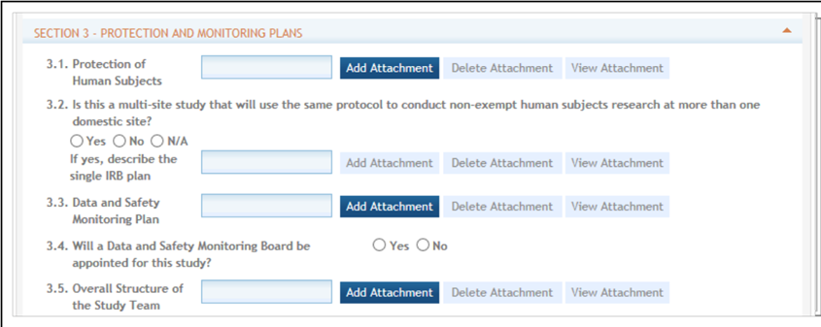
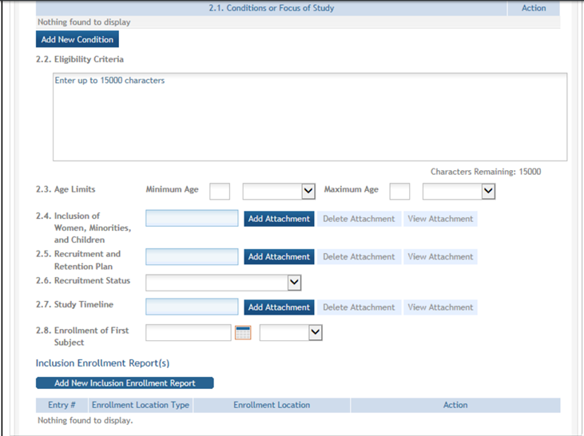
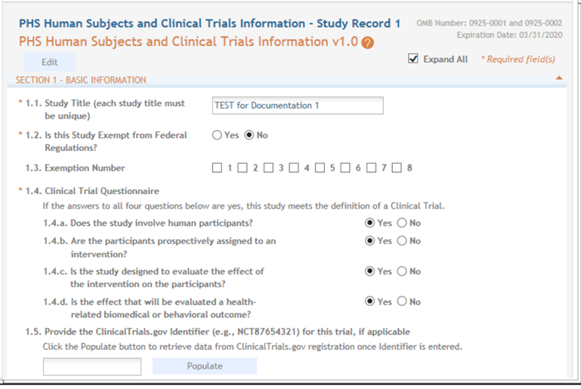
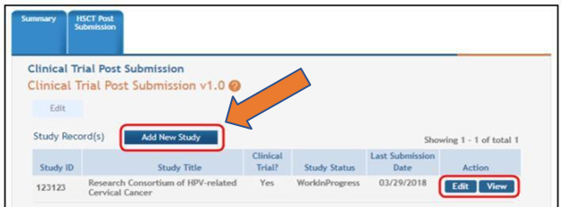

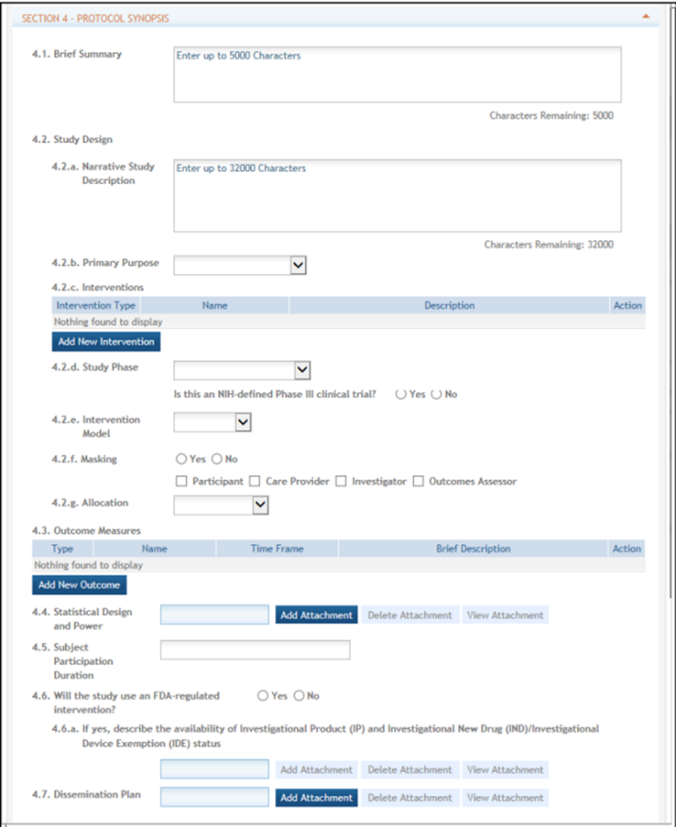

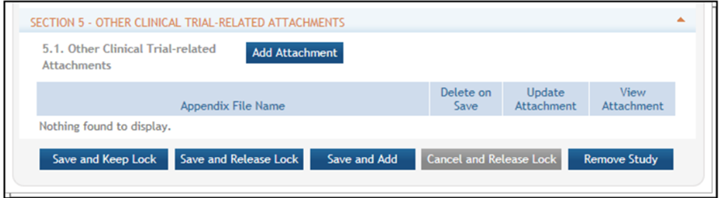

- Once the study is saved, it will be added to the Study Record table
- Multiple steps must be completed for submission of a New Study; please ensure that all steps have been taken.
  - Save & Lock/Save & Release Lock: PI or SO
  - Ready for Submission: PI or SO
  - Submit: SO only
  - After submission of a study by the SO, the study status must be changed manually to “Work In Progress.” This will allow another New Study to be added.
- SO notification to NCATS of submission of a new HSR study to HSS: see Section II for instructions.

SECTION V. REVIEW PROCESS & RESPONDING TO REQUESTS FOR CLARIFICATION OR ADDITIONAL INFORMATION
  - Category 1
    - NCATS will conduct a review, primarily of the safety aspects of the described study/trial, and an administrative review of required documents. NCATS will initiate review of the request and notify (via email) the PI/SO of the outcome within 30 calendar days. NCATS may request clarification or revisions via email to the SO. SOs should: a. Submit any clarifications/revisions into the eRA HSS module, and b. Send an email response to NCATS that includes a description of the changes to the documents. Please note that if a request is returned for any reason, the 30-day turnaround time resets. HSR study/trial may not begin until approval is received from the GMS.
  - Category 2
    - NCATS will conduct a timely, high-level review to confirm that the described study appears to meet Category 2 criteria and will conduct an administrative review of required documents. NCATS may submit questions to the institution and require the site to stop HSR activities if the submitted documentation does not support Category 2 criteria.

SECTION VI. BACKGROUND INFORMATION
- eRA Human Subjects System
NIH developed the Human Subjects System (HSS), which consolidates human subjects and clinical trial information in one place, as part of its larger effort to comply with 21st Century Cures requirements to enhance accountability and transparency in NIH clinical research. HSS is a shared system, used both by principal investigators and signing officials on one hand and by NIH staff on the other. The system was launched in June 2018 and replaced the Inclusion Management System (IMS) used for reporting participant sex/gender, race, and ethnicity information. HSS is accessed via the Human Subjects link in eRA Commons (via the Status tab or the RPPR tab). The Human Subjects link will only be visible if the application/grant is marked “yes” for human subjects research.
- Award Recipient Features in HSS
  - Pre-award (post review) for just-in-time information or correction of human subjects data
  - Post-award to add/update human subjects study information; create new inclusion enrollment reports; or view/edit/update existing enrollment data when submitting a Research Performance Progress Report (RPPR)
    - Convert a delayed onset study to a full study record, once detailed study information is available
    - Add a New Study (For NCATS awards: already IRB-approved and all required documents are available)
    - Add a New Delayed Onset Study (must provide justification for why details of the study will not be available until later)
  - Off-cycle updates as required in the Funding Opportunity Announcement or terms and conditions of award, e.g., to add a New Study for Prior Approval
  - Provide interim data as requested by NIH staff
  - Inform NIH of ClinicalTrials.gov registration

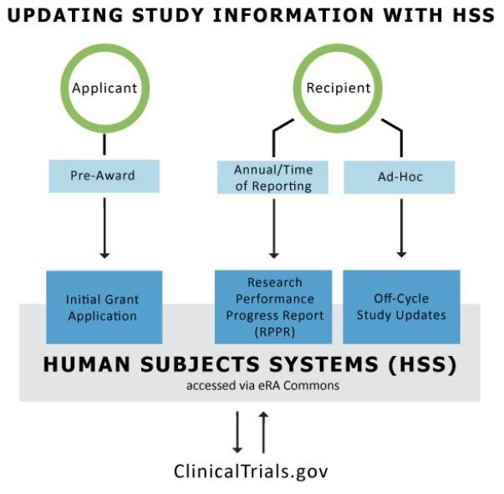
Important Note: The Human Subjects and Clinical Trials Information form appears for all recipients with human subjects studies. However, those who submitted competing applications prior to January 25, 2018 only need to update inclusion data via the Human Subjects link in the RPPR. The remaining fields (e.g., milestones) are not required to be filled out.
Those who submitted applications on or after January 25, 2018, may need to fill out more fields than the inclusion data for their RPPR.

SECTION VII. DEFINITIONS
- NIH Definition of Clinical Research: Research with human subjects that is: 1) Patient-oriented research. Research conducted with human subjects (or on material of human origin such as tissues, specimens, and cognitive phenomena) for which an investigator (or colleague) directly interacts with human subjects. Excluded from this definition are in vitro studies that utilize human tissues that cannot be linked to a living individual. It includes: (a) mechanisms of human disease, (b), therapeutic interventions, (c) clinical trials, or (d) development of new technologies. 2) Epidemiological and behavioral studies. 3) Outcomes research and health services research.
- NIH Definition of Clinical Trial: A research study in which one or more human subjects are prospectively assigned to one or more interventions (which may include placebo or other control) to evaluate the effects of those interventions on health-related biomedical or behavioral outcomes.
- HHS Definition of Human Subjects Research: According to 45 CFR 46 Link to Non-U.S. Government Site - Click for Disclaimer, a human subject is "a living individual about whom an investigator (whether professional or student) conducting research:
- Obtains information or biospecimens through intervention or interaction with the individual, and uses, studies, or analyzes the information or biospecimens; or
- Obtains, uses, studies, analyzes, or generates identifiable private information or identifiable biospecimens.
  - New Study means that a study was not included in the grant application; studies are identified and added after award. You include none of the required supporting material with the application. A new human subjects project must be entered into the HSS as a NEW STUDY and may require Prior Approval from your NCATS Program Director and Grants Management Official. Reminder: NCATS requires that IRB approval or institutional determination of exemption be obtained prior to entry into the HSS.

SECTION VIII. RESOURCES
Process Overview

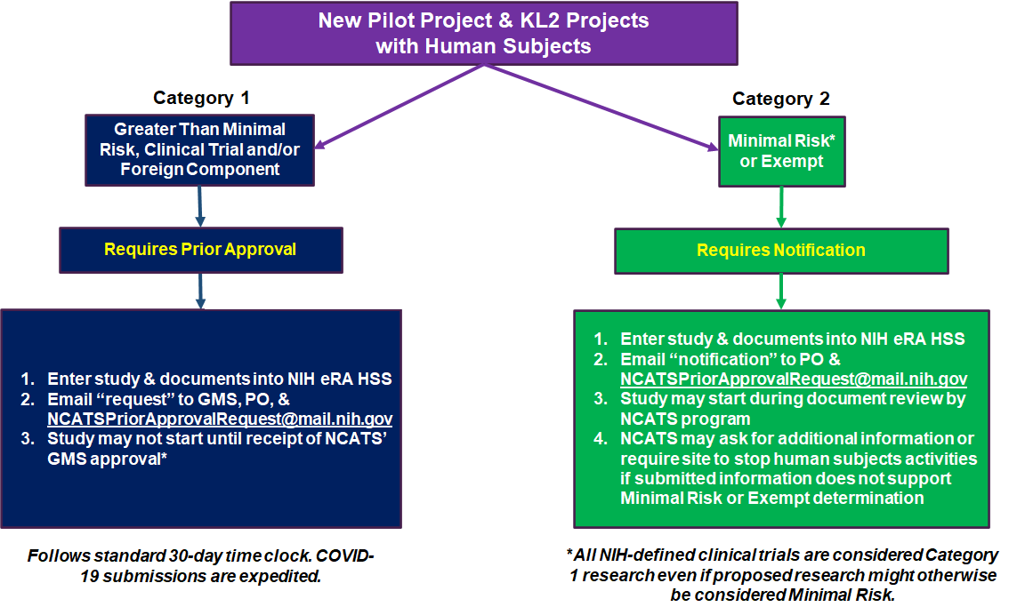

Useful Links

  - OER Inclusion inbox for HSS and inclusion policy-related questions: inclusion@od.nih.gov
  - https://humansubjects.nih.gov/
  - 45CFRPart46
  - https://era.nih.gov/hss_training.htm
  - https://era.nih.gov/files/HSS_user_guide.pdf
  - https://era.nih.gov/files/assist_user_guide.pdf
  - https://grants.nih.gov/grants/how-to-apply-application-guide/format-and-write/format- attachments.htm (required format of attachments)
  - https://ncats.nih.gov/ctsa/funding/prior-approval-faq
  - https://grants.nih.gov/policy/clinical-trials/human-subjects-system.htm
  - https://era.nih.gov/erahelp/assist/Content/ASSIST_Help_Topics/3_Form_Screens/PHS_HS_CT/PHS_Summary.htmh
  - https://ncats.nih.gov/ctsa/funding/prior-approval-faq#clarification
  - https://grants.nih.gov/grants/funding/inclusion-basis-on-sex-gender-race-ethnicity-faq.htm#5510
  - https://grants.nih.gov/grants/funding/women_min/inclusion_training.htm
  - https://grants.nih.gov/grants/how-to-apply-application-guide/forms-e/general-forms-e.pdf
  - https://grants.nih.gov/grants/how-to-apply-application-guide/forms-e/multi-project-forms-e.pdf

For assistance with this Addendum or requested content, please contact NCATSDOPAinquiry@mail.nih.gov

For assistance with the eRA HSS, please contact the eRA Service Desk https://grants.nih.gov/support/index.html
Toll-free: 1-866-504-9552 (Press 1 for eRA Commons or ASSIST)
Phone: 301-402-7469 (Press 1 for eRA Commons or ASSIST)
Hours: Mon-Fri, 7 a.m. to 8 p.m. ET (closed on federal holidays)

