The QA/QC Discussion Forum can be accessed from the CLIC website: https://clic-ctsa.org/groups/discussion-forums | 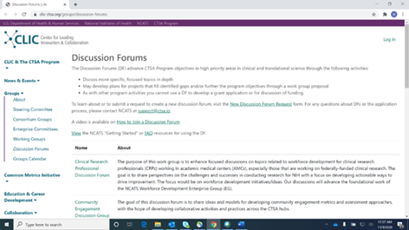
Scroll down to the NCATS CTSA Program Quality Assurance/Quality Control Group | 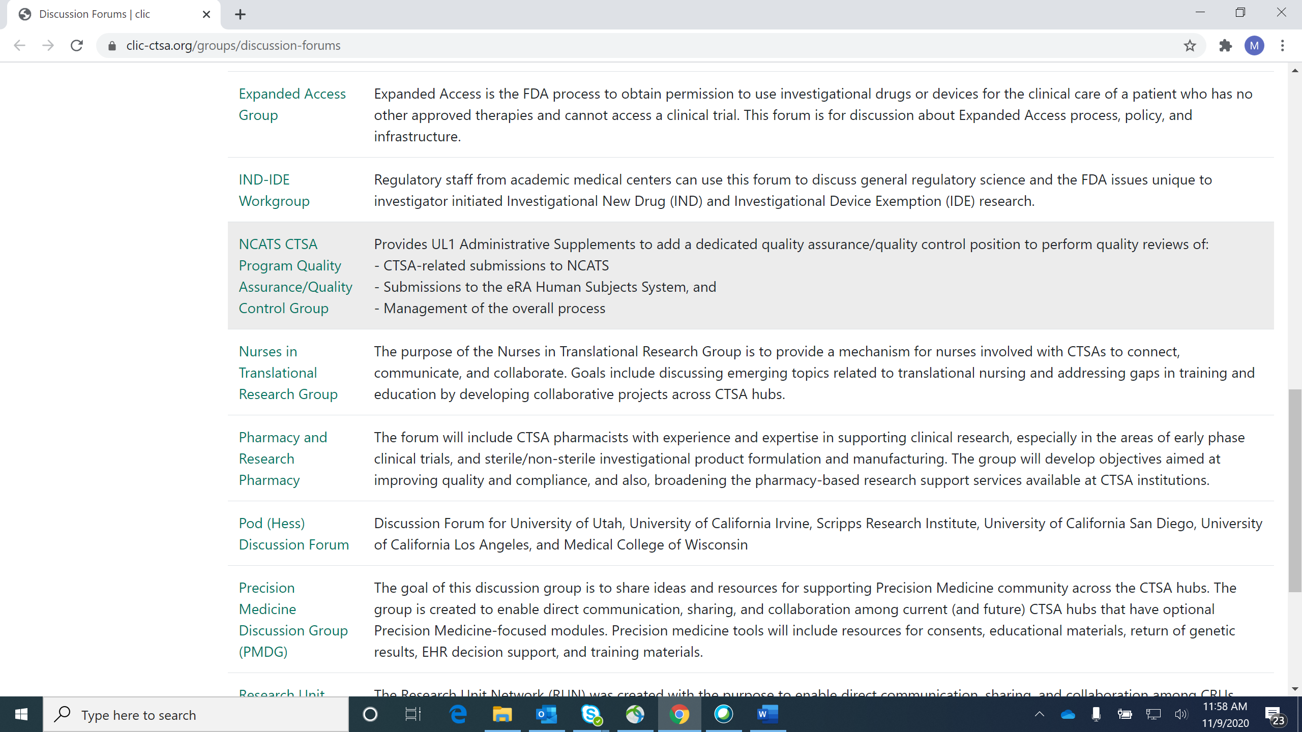
Once you have clicked on the NCATS CTSA Program Quality Assurance/Quality Control Group link it will take you to the welcome page.  Note: Users that are not able to log in with their institutional credentials can apply for special access using the “Click here to apply” link on the form. https://docs.google.com/forms/d/e/1FAIpQLSfjZYaK-iXBNHGgWcR9kUhE2icDEGcvYq-ZJX8hmmF8IXCsag/viewform | 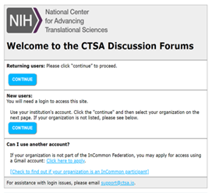
Click "Continue" which will take the user to a login page where users can select their organization and log in. | 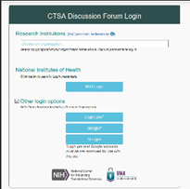
Once logged in the user will see the DF home page (https://www.google.com/a/ctsa.io/ServiceLogin?continue=https://sites.google.com/a/ctsa.io/ctsa-qaqc). | 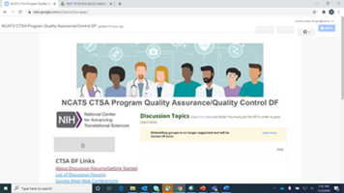
From the homepage they will have the option to apply to join the DF by clicking the green button labeled “Apply to Join the DF” (on the left of the screen) | 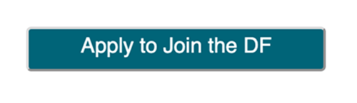
Please bookmark the Discussion Forum Page for ease of access!

Email and Forwarding
CTSA.IO Email
When you log into the CTSA.IO G Suite site your email address is mapped to a new Gmail address with the @ctsa.io extension. For example, if you logged in with jj@xyz.edu, your ctsa.io account would be jj.xyz.edu@ctsa.io. You can access this email at http://mail.ctsa.io. Google will send various notifications to this address, including requests to join the DF.

Automatic Email Forwarding
If you are new to the CTSA.IO G Discussion Forums you will receive an email inviting you to forward your CTSA.IO emails to the email account that you use to log in. Follow the instructions in this email to have your notifications automatically sent to your normal email. This can alleviate the need to manage an additional email account. If you have questions about email forwarding, please contact support@ctsa.io.

Handy Shortcuts
The following links for the DF include a special prefix which ensures that your login will use the correct account. Drag a link into your bookmark bar or copy and paste it to share with others. These links are also available on the home page of the DF.
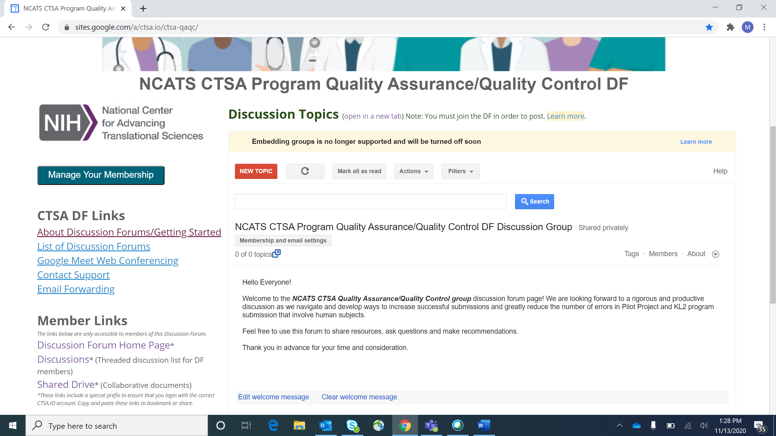

[Note: You should add this prefix, https://www.google.com/a/ctsa.io/ServiceLogin?continue=, to any CTSA.IO links that you want to share to improve the login experience for users.]

- Discussion Forum Home Page (https://www.google.com/a/ctsa.io/ServiceLogin?continue=https://sites.google.com/a/ctsa.io/ctsa-qaqc)
- Discussion Posts (this link is to the chat feature. Access is located on the main landing page under the “Discussions” link. Then click the “start a conversation!” link to initiate a chat/discussion) (https://www.google.com/a/ctsa.io/ServiceLogin?continue=https://groups.google.com/a/ctsa.io/forum/%23!forum/ctsa-qaqc-discuss)
- Shared Drive (access/link to the shared drive is located on the main landing page) (https://www.google.com/a/ctsa.io/ServiceLogin?continue=https://drive.google.com/drive/folders/0AMh4Af25HoWvUk9PVA)

For questions or other assistance with the DF, please contact support@ctsa.io.

