NCATS NEW PROJECTS WITH HUMAN SUBJECTS RESEARCH

ADDENDUM
Does the study include a foreign component? | ☐ Yes ☐ No | For studies proposing to include a foreign component. Official notification of foreign component prior approval will only be received via a revised notice of grant award.
Did the foreign component receive official NCATS Prior Approval notification? | ☐ Yes ☐ No ☐ N/A | If "No", please do not complete the rest of the form. See section II on page 3 for instructions to receive foreign component approval.

SECTION I
Read each section and complete according to the instructions provided.
Name of UL1/UM1 Pilot Study Principal Investigator (PI) or KL2/K12 Scholar or UM1 Element E Research Project (Designated Study PI) | Click here to enter text.
Title* of Proposed Research Protocol  *This must match the title on the IRB-Approval documentation | Click here to enter text.
Type of Proposed Research | ☐ UL1/UM1 Pilot Project ☐ KL2/K12 Scholar Project  ☐ UM1 Element E Project
Category 1 Research  Requires entry & document upload into HSS and official NCATS approval by GMS before human subjects research begins. | ☐ Greater Than Minimal Risk (as designated by institution and/or IRB)  ☐ Clinical Trial (NIH-defined)  (regardless of the risk level, based on NIH definition)
Category 2 Research  Requires entry & document upload into HSS and notification of NCATS before human subjects research begins. | ☐ Exempt  Exemption # ☐1 ☐2 ☐3 ☐4 ☐5 ☐6 ☐7 ☐8  Existing data with personal identifiable information (PII)# ☐ Yes ☐ No  ☐ Minimal Risk *All NIH-defined clinical trials are considered Category 1 research even if proposed research might otherwise be considered Minimal Risk.
Title and PI of Parent Study (if proposed research is ancillary to another study) | Click here to enter text.
Is this study collecting genomic data?  See: NIH Genomic Data Sharing | ☐ Yes ☐ No
Translational Stage(s) of Research  (definitions) | ☐ Preclinical ☐ Clinical  ☐ Clinical Implementation ☐ Public Health
NCATS Program Director/Program Officer (PO) | Click here to enter text.
NCATS Grants Management Specialist (GMS) | Click here to enter text.
Institutional Signing Official (SO) | Click here to enter text.
Institutional QA/QC Key Personnel | Click here to enter text.
Date form completed (MM/DD/YYYY) | Click here to enter text.

(#) Studies that use existing data with PII are not considered exemption 4.
ADDENDUM

SECTION II

- For UL1/UM1 pilots and KL2/K12 projects: provide a brief (< 500 words) summary of the specific aspects of the proposed study that will be supported by NCATS funds.
For UM1 Element E projects include the following: the overall focus of the CTS Research Program. Specific Aims, rationale, and approach to the selection of the proposed CTS research project(s); and how the project(s) will provide generalizable innovations or insights that increase the overall efficiency or effectiveness of translation. A plan for dissemination of successful projects; include a proposed impact statement should the project ultimately be successful. The description should not exceed 6 pages and be uploaded at the end of the addendum.
Click here to enter text.

- List a line-item budget for each specific aspect to be supported with NCATS funds (list supplies, services, and personnel costs). Please note: KL2/K12 Scholar salaries should not be included in the budget. UM1 Element E projects may not be less than $125,000 and must not exceed $500,000 direct costs, for a suggested period of 2-3 years. For UM1 pilots may not be less than $25,000 and not more than $50,000 direct costs and cannot exceed 12 months.

Click here to enter text.

- If the proposed research is considered an amendment or is a sub-study/ancillary study to an IRB-approved parent protocol, provide a summary of the parent protocol with an explanation of how the proposed study connects to it.

Click here to enter text.

- List names of Key Personnel involved in the proposed project.
Click here to enter text.

INSTRUCTIONS

SECTION I. NOTES
  - NIH policy, requires that all Human Subjects Research (HSR) studies must be submitted via the eRA Human Subjects System (HSS).
    - HSS currently functions as a document repository, so e-mail should be used for communications between the submitter and NCATS Program and Grants Management staff.
    - The HSS, ASSIST, and G-500 User Guides are very useful.
    - NIH eRA HSS guidance received to date indicates that to enter a New Study, the grant must indicate “yes” for human subjects research.
    - Inclusion enrollment monitoring is required for all human subjects research except HSR meeting the regulatory criteria for Exemption 4 and KL2/K12 scholar projects. However, if the KL2/K12 Scholar is conducting an independent clinical research that is only using KL2/K12 research funds to support the trial, then the IER is required. If you have questions about whether inclusion enrollment monitoring is required for your study, please contact your NCATS Program Officer.
      - NCATS compiles discrepancy reports for IER about every 2 months. These discrepancies are reported through the PO to the hub for corrections. Cumulative enrollment is expected to be monitored and updated regularly over the course of the study. IERs are required to be up-to-date prior to RPPR submission.
    - Inclusion Across the Lifespan Policy requires providing age data for the enrolled participants.

Comply with the Inclusion of Women and Minorities as Participants in Research Involving Human Subjects

  - All new Projects with HSR must have IRB approval or institutional determination of exemption prior to submission and relevant documentation must be provided.

SECTION II. DOCUMENT PREPARATION, SUBMISSION, & INSTRUCTIONS
- Foreign component studies: require prior approval and must receive approval from the NCATS Grants Management Specialist (GMS) BEFORE they are submitted for prior approval to conduct human subjects research. Failure to receive prior approval of a foreign component will result in the human subjects prior approval being rejected. See NCATS process for prior approval of foreign components here.
- Confirm that all sections of HSS and the Addendum are completed accurately and that all required documents are included prior to submission and NCATS notification.
- Formatting
- Include footers on individual PDF documents to identify (IRB-approval, biosketches, etc.) prior to combining into a single PDF document.
- HSS only accepts PDFs and only one combined PDF per study uploaded to Section 2.7 or 5.1 (see below). Convert each required document into a PDF and then combine into a single PDF file in the order specified under each category, below, when applicable.
- Do not scan to convert to PDF, as the quality will degrade.
- Category 1: Greater Than Minimal Risk studies and /or NIH-defined Clinical Trials
  - See Section III for a summary of NCATS required documents and eRA HSS sections to be completed.
  - Collect specified documents as PDFs, add footers to each PDF, combine into a single PDF file in the following order, and name the combined PDF file HSRPA1 _CTSA Institution_ Study PI Last Name_Date
    - Addendum Sections I and II (the first 2 pages of this document and up to 6 pages for element E if applicable)
    - Certification of IRB-Approval
    - Biosketches for the PI and key personnel
    - Institutional letter attesting to completion of Human Subjects Training for PI and key personnel
    - IRB-Approved Protocol
    - IRB-Approved informed consent, verbal consent transcript, assent and parental permission documents, or documentation of IRB waiver (as applicable)
    - Study Timeline
      - Greater than Minimal Risk - add the Study Timeline to the combined PDF
      - NIH-Defined CTs – upload Study Timeline to Section 2.7 as single PDF
  - Enter new study into eRA HSS and upload the combined PDF to HSS Section:
    - 5.1 for NIH-Defined Clinical Trials
    - 2.7 for Greater than Minimal Risk studies
  - SO submits the new study and required documents via eRA HSS
  - SO notifies NCATS via email to assigned PO, GMS and mailbox mailto:NCATSPriorApprovalRequest@mail.nih.gov with the suggested SUBJECT line: NCATS CTSA Pilot/KL2/K12/element E Research project HS Study XXX {insert HSS study number} Notification. HSR study/trial may not begin until approval is received from the Grants Management Specialist (GMS).
- Category 2: Minimal Risk and Exempt Studies
  - See Section III for a summary of NCATS required documents and eRA HSS sections to be completed.
  - Collect specified documents as PDFs, add footers to each PDF, combine into a single PDF file in the following order, and name the combined PDF file HSRPA2_CTSA Institution_ Study PI Last Name_Date
- Addendum Sections I and II (the first 2 pages of this document and up to 6 pages for element E if applicable)
- Certification of IRB-Approval
- Institutional letter attesting to completion of Human Subjects Training for PI and key personnel
- Study Timeline
  - Enter new study into eRA HSS
    - Upload the combined PDF file to HSS Section 2.7
  - SO submits the new study and required documents via eRA HSS
  - SO notifies NCATS via email to assigned PO, GMS, and mailbox NCATSPriorApprovalRequest@mail.nih.gov with the suggested SUBJECT line: NCATS CTSA Pilot/KL2/K12/element E Research project HS Study XXX {insert HSS study number} Notification. Submission by the SO serves as institutional verification of the Minimal Risk or Exempt determination and completion of Human Subjects Training for PI and key personnel.
  - Failure to submit the required documentation prior to project start may result in non-compliance enforcement actions.

SECTION III. SUMMARY OF NCATS REQUIRED DOCUMENTS & ERA HSS SECTIONS TO BE COMPLETED

NCATS REQUIRED DOCUMENTS | Category 1¹ |  | Category 2²
STUDY CATEGORY | Clinical Trial | Greater Than Minimal Risk Study | Minimal Risk³, Exempt 1-3; 5-8 Study⁶ | Exemption 4
COMPLETE HSS SECTIONS⁵ | 1-6 | 1, 2, 3.1 & 3.2 | 1, 2, 3.1 & 3.2 | 1, 3.1 & 3.2
Addendum | √ | √ | √ | √
Certification of IRB-Approval | √ | √ | √ or  √
Institutional Exemption Determination |  |  |  | √
Biosketches for PIs and key personnel | √ | √
Institutional letter attesting to completion of Human Subjects Training for PI and key personnel⁴ | √ | √ | √ | √
IRB-Approved Protocol | √ | √
IRB-Approved informed consent, verbal consent transcript, assent and parental permission documents, or documentation of IRB waiver (as applicable) | √ | √
Specified NCATS Required Document PDFs should be combined and attached in HSS Sections | 5.1 | 2.7  (Study Timeline attachment box must be used to attach the Study Timeline plus the NCATS-specified documents.)

¹Category 1 Human Subjects Research that meets the NIH definition of a clinical trial. Answered “Yes” to all the questions in HSS Section 1.4 - Clinical Trial Questionnaire. OR Human Subjects Research study deemed Greater than Minimal Risk by IRB.
²Category 2 Human Subjects Research study deemed Minimal Risk by the IRB or study has been determined by the institution to meet the criteria for Exemptions 1-8 under 45CFR46.
³All NIH-defined clinical trials are considered Category 1 research even if proposed research might otherwise be considered Minimal Risk.
⁴Institutional letter attesting to completion of Human Subjects Training for PI and key personnel: NIH policy (NOT-OD-00-039 & NOT-OD-01-061) requires education on the protection of human research participants for PI and all key personnel; insert signed letter.
⁵Utilize G.500 – PHS Human Subjects and Clinical Trials Information as a guide during the preparation of any HSS Section required for Category 1 or Category 2 Prior Approval submissions.
⁶ Existing data with personal identifiable information (PII) is included in this category.

eRA HSS SECTIONS to be COMPLETED⁶ |  | Category 1¹ |  | Category 2²
STUDY CATEGORY |  | Clinical Trial | Greater Than Minimal Risk Study | Minimal Risk³, Exempt 1-3; 5-8 Study⁹ | Exemption 4
HSS Section 1 – Basic Information
1.1 | Study Title | √ | √ | √ | √
1.2 | Is this Study Exempt from Federal Regulations? | √ | √ | √ | √
1.3 | Exemption Number | √ | √ | √ | √
1.4 | Clinical Trial Questionnaire | √ | √ | √ | √
1.5 | Provide the ClinicalTrials.gov Identifier | √
HSS Section 2 – Study Population Characteristics
2.1 | Conditions or Focus of Study | √ | √ | √
2.2 | Eligibility Criteria | √ | √ | √
2.3 | Age Limits | √ | √ | √
2.3.a | Inclusion of Individuals Across the Lifespan | √ | √ | √
2.4 | Inclusion of Women & Minorities | √ | √ | √
2.5 | Recruitment and Retention Plan | √ | √ | √
2.6 | Recruitment Status | √ | √ | √
2.7 | Study Timeline | √ | √ | √
2.8 | Enrollment of First Participant (Section 6.3) | √⁴ | √⁴ | √⁴
2.9 | Inclusion Enrollment Report(s) | √⁷ | √⁷ | √⁷
HSS Section 3 – Protection and Monitoring Plans
3.1 | Protection of Human Subjects | √ | √ | √ | √
3.2 | Is this a multi-site study? | √⁵ | √⁵ | √⁵ | √⁵
3.3 | Data and Safety Monitoring Plan | √ | Optional | Optional | Optional
3.4 | Data and Safety Monitoring Board | √ | Optional | Optional | Optional
3.5 | Overall Structure of the Study Team | √ | Optional | Optional | Optional
HSS Section 4 – Protocol Synopsis
4.1 | Study Design | √
4.1.a | Detailed Description | √
4.1.b | Primary Purpose | √
4.1.c | Interventions | √
4.1.d | Study Phase | √
4.1.e | Intervention Model | √
4.1.f | Masking | √
4.1.g | Allocation | √
4.2 | Outcome Measures | √
4.3 | Statistical Design and Power | √
4.4 | Subject Participation Duration | √
4.5 | FDA-Regulated Intervention? (IND/IDE) | √
4.7 | Dissemination Plan | √
HSS Section 5 – Other Clinical Trial Attachments
5.1 | Other Clinical Trial Attachments | √
HSS Section 6 – Clinical Trial Milestone Plan⁸
6.1 | Study Primary Completion Date | √⁸
6.2 | Study Final Completion Date | √⁸
6.3 | Enrollment and Randomization | √⁸ | √⁸ | √⁸
6.4 | Completion of primary endpoint data analyses | √⁸
6.5 | Reporting of results in ClinicalTrials.gov | √⁸
6.6 | Is this an applicable clinical trial under FDAAA? | √⁸
¹Category 1 Human Subjects Research that meets the NIH definition of a clinical trial (Answered “Yes” to all the questions in HSS Section 1.4 - Clinical Trial Questionnaire) OR Human Subjects Research study deemed Greater than Minimal Risk by IRB.
²Category 2 Human Subjects Research study deemed Minimal Risk by the IRB or study has been determined by the institution to meet the criteria for Exemptions 1-8 under 45 CFR 46
³All NIH-defined clinical trials are considered Category 1 research even if proposed research might otherwise be considered Minimal Risk.
⁴Section 2.8 Enrollment of First Participant: This field is now populated in Section 6.3 in HSS. Do not complete this field if you answered “YES” to the question “Using an Existing Data Set or Resources?” in the Inclusion Enrollment Report.
⁵Section 3.2 Multi-site Studies: Answer "Yes/No;" or select N/A only if: a. You answered “Yes” to “Question 1.2 Is this Study Exempt from Federal Regulations?”.See G.500 for reference.
⁶Utilize G.500 – PHS Human Subjects and Clinical Trials Information as a guide during the preparation of any HSS Section required for Category 1 or Category 2 Prior Approval submissions.
⁷Section 2.9 Inclusion Enrollment Report(s) is not required for KL2/K12 Scholar projects and Category 4 Exempt HSR ( note: If the KL2/K12 Scholar is conducting an independent clinical trial that is only using KL2/K12 research funds to support the trial, then the IER is required.)
⁸Section 6.3 Anticipated Enrollment of 1st participant is required for all prior approval submissions except Exempt Category 4. Even though Section 6 was initially created for clinical trials, the enrollment start must be included and updated for ALL HSR projects (including exempt studies, other than category 4) before submitting the RPPR.
For clinical trials, the other fields in Section 6 will populate when the NCT number is entered in Section 1.5 and the ‘populate’ button is pushed. However, this is not required for prior approval submission but must be populated within 21 days of enrollment of the first participant. The information from clinicaltrials.gov will populate the HSS fields so ensure the clinicaltrials.gov entry is current upon HSS completion.
⁹ Existing data with personal identifiable information (PII) is included in this category.

SECTION IV. HSS SUBMISSION PROCESS
  - All new HSR UL1/UM1 Pilot Projects, new KL2/K12 Scholar Projects, and new UM1 Element E Research Projects (not submitted with the original application) require entry of a new study into the HSS. Delayed onset UM1 Element E Research Projects will need to update their HSS records.
  - You can find HSS video tutorials here
  - Once in the HSS module, the PI/SO/QA/QC Personnel clicks the “Add New Study” button and enters all required study-related information. Complete HSS fields and attach HSS and NCATS specified documents. You can find screenshots and instructions for HSS completion starting on page 123 of the ASSIST User Guide.
- Once the study is saved, it will be added to the Study Record table.
- Please ensure that these steps have been taken when entering a New Study:
  - Save & Keep Lock/Save & Release Lock: PI, SO, or QA/QC Personnel
  - Ready for Submission: PI, SO, or QA/QC Personnel
  - Submit: SO only
  - After submission of a study by the SO, the study status must be changed manually to “Work In Progress.” This will allow another New Study to be added.
- SO notification to NCATS of submission of a new HSR study to HSS: see Section III above for instructions.

SECTION V. HSS BACKGROUND INFORMATION
- eRA Human Subjects System
NIH developed the Human Subjects System (HSS), which consolidates human subjects and clinical trial information in one place, as part of its larger effort to comply with 21st Century Cures requirements to enhance accountability and transparency in NIH clinical research. HSS is a shared system, used both by principal investigators and signing officials on one hand and by NIH staff on the other. The system was launched in June 2018 and replaced the Inclusion Management System (IMS) used for reporting participant sex/gender, race, and ethnicity information. HSS is accessed via the Human Subjects link in eRA Commons (via the Status tab or the RPPR tab). The Human Subjects link will only be visible if the application/grant is marked “yes” for human subjects research.
- CTSA Award Recipient Features in HSS
  - Pre-award (post review) for just-in-time information or correction of human subjects data
  - Post-award to add/update human subjects study information; create new inclusion enrollment reports; or view/edit/update existing enrollment data when submitting a Research Performance Progress Report (RPPR)
    - Complete study start and end date in section 6.3 (Note: start and end date for clinical research and clinical trials can be updated in this section).
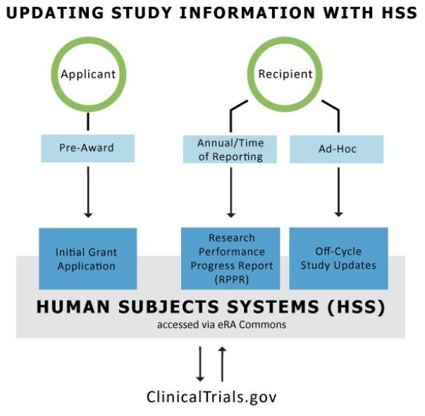
  - Off-cycle updates as required in the Funding Opportunity Announcement or terms and conditions of award, e.g., to add a New Study for Prior Approval
  - Provide interim data as requested by NIH staff
  - Inform NIH of ClinicalTrials.gov registration
Important Note: The Human Subjects and Clinical Trials Information form appears for all recipients with human subjects studies. However, those who submitted competing applications prior to January 25, 2018 only need to update inclusion data via the Human Subjects link in the RPPR. The remaining fields (e.g., milestones) are not required to be filled out.
Those who submitted applications on or after January 25, 2018, may need to fill out more fields than the inclusion data for their RPPR.

SECTION VI. NCATS REVIEW PROCESS & RESPONDING TO REQUESTS FOR CLARIFICATION OR ADDITIONAL INFORMATION
Reminder: Award funds may be spent on non-human subjects research activities before NCATS Prior Approval as long as other NCATS prior approval requirements do not apply (e.g., for research involving live vertebrate animals).
  - Category 1
    - NCATS will conduct a review, primarily of the safety aspects of the described study/trial, and an administrative review of required documents. NCATS will initiate review of the request and notify (via email) the PI/SO of the outcome within 30 calendar days. NCATS may request clarification or revisions via email to the SO. SOs should:
a. Submit any clarifications/revisions into the eRA HSS module, and
b. Send an email response to NCATS that includes a description of the changes to the documents.
    - Please note that if a request is returned for any reason, the 30-day turnaround time resets. HSR study/trial may not begin until approval is received from the GMS.
  - Category 2
    - NCATS will conduct a timely, high-level review to confirm that the described study appears to meet Category 2 criteria and will conduct an administrative review of required documents. NCATS may submit questions to the institution and require the site to stop HSR activities if the submitted documentation does not support Category 2 criteria.
Process Overview

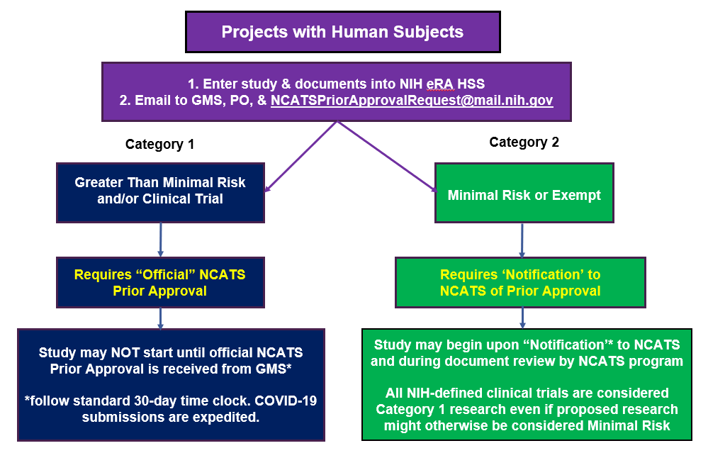

APPENDIX

SECTION I. DEFINITIONS
- NIH Definition of Clinical Research: Research with human subjects that is: 1) Patient-oriented research. Research conducted with human subjects (or on material of human origin such as tissues, specimens, and cognitive phenomena) for which an investigator (or colleague) directly interacts with human subjects. Excluded from this definition are in vitro studies that utilize human tissues that cannot be linked to a living individual. It includes: (a) mechanisms of human disease, (b), therapeutic interventions, (c) clinical trials, or (d) development of new technologies. 2) Epidemiological and behavioral studies. 3) Outcomes research and health services research.
- NIH Definition of Clinical Trial: A research study in which one or more human subjects are prospectively assigned to one or more interventions (which may include placebo or other control) to evaluate the effects of those interventions on health-related biomedical or behavioral outcomes.
- HHS Definition of Human Subjects Research: According to 45 CFR 46 Link to Non-U.S. Government Site - Click for Disclaimer, a human subject is "a living individual about whom an investigator (whether professional or student) conducting research:
- Obtains information or biospecimens through intervention or interaction with the individual, and uses, studies, or analyzes the information or biospecimens; or
- Obtains, uses, studies, analyzes, or generates identifiable private information or identifiable biospecimens.”
  - New Study means that a study was not included in the grant application; studies are identified and added after award. You include none of the required supporting material with the application. A new human subjects project must be entered into the HSS as a NEW STUDY and may require Prior Approval from your NCATS Program Director and Grants Management Official. Reminder: NCATS requires that IRB approval or institutional determination of exemption be obtained prior to entry into the HSS.

SECTION II. PAY PARTICULAR ATTENTION TO THE FOLLOWING
- Most Common Issues with Prior Approval Requests
  - Inaccurate/incomplete HSS fields
  - Incomplete submissions (missing, inaccurate, or inconsistent documents; inadequate information)
  - Overall quality of the materials
  - Adherence to NIH and NCATS policies
- NCATS Phase III Clinical Trial Policy (NIH Guide Notice NOT-TR-18-025)
  - NCATS is prohibited from direct funding of NIH-defined Phase III CT unless the target is a rare disease or condition, and follows specific steps prior to funding (public notice for ≥120 days )
  - Please refer to NIH-approved definitions of clinical trials here
- Accurate completion of the Human Subjects System “PHS Human Subjects and Clinical Trials Information” Section, including accurate identification of clinical trials
  - Study investigator/KL2/K12 Scholar should review the available resources to clarify definitions (i.e., case studies, FAQs and decision tree) at https://grants.nih.gov/policy/clinical-trials/definition.htm and consult with a clinical trial specialist at the CTSA hub or a designated point of contact for quality assurance/quality control (QA/QC) before submitting information to include in the study record to the institutional POC.
  - If a pilot/project is extended (without need for a prior approval request for carryover of the budget) due to unforeseen circumstances but the science, scope, and risk level remains the same as the originally submitted and approved pilot/project, the extended pilot/project can proceed without an additional prior approval if all prior documentation covers the extended period.
  - If a study meets the criteria for an NIH-defined clinical trial, the study investigator/scholar must comply with the registration and reporting requirements for Applicable Clinical Trials (https://prsinfo.clinicaltrials.gov/ACT_Checklist.pdf) and/or the NIH Policy on the Dissemination of NIH-Funded Clinical Trial Information.
- Inclusion Enrollment Information:
  - The Planned Enrollment Table in the Inclusion and Enrollment Report (IER) ASSIST 2.9 must be accurate (number of participants, racial categories, and ethnic categories) and must match the described project and all supporting documentation. Note: The Actual (Cumulative) Enrollment Table must be updated in the IER (ASSIST 2.9) at the time of submission of the annual RPPR including and age at enrollment
  - https://era.nih.gov/erahelp/assist/Content/ASSIST_Help_Topics/3_Form_Screens/PHS_HS_CT/Incl_Enroll_Rprt.htm
  - Inclusion policies: https://grants.nih.gov/policy/inclusion.htm
- Research Involving Prisoners
  - In addition to Subpart C of the Common Rule (45 CFR 46), an institution that intends to conduct HHS-supported research involving prisoners as subjects must certify to the Secretary (through OHRP) that the IRB has made the seven findings required under 45 CFR 46.305(a), including the finding that the proposed research represents one of the permissible categories of research under 45 CFR 46.306(a)(2).
  - In general, research involving prisoners cannot be designated as exempt from regulatory requirements. However, the revised Common Rule exempts (46.104(b)(2) research “aimed at involving a broader subject population that only incidentally includes prisoners”.
  - More detailed information about Biomedical and Behavioral Research Involving Prisoners as Subjects:
    - Subpart C—Additional Protections Pertaining to Biomedical and Behavioral Research Involving Prisoners as Subjects: https://www.ecfr.gov/cgi-bin/text-idx?SID=c55504b292fe7481954eb30808ae2336&mc=true&node=pt45.1.46&rgn=div5
    - Guidance on Approving Research Involving Prisoners: https://www.hhs.gov/ohrp/regulations-and-policy/guidance/prisoner-research-certification/index.html
    - Prisoner Research Certification: https://www.hhs.gov/ohrp/regulations-and-policy/guidance/prisoner-research-certification/index.html
    - Prisoner Research FAQs: https://www.hhs.gov/ohrp/regulations-and-policy/guidance/faq/prisoner-research/index.html
- Human Fetal Tissue Policy
  - CTSA Hubs must contact the assigned Program Officer and Grants Specialist of any potential use of human fetal tissue prior to submitting the research project in to the HSS system. Any proposed use of human fetal tissue research supported via direct funding and/or voluntary committed cost share requires NCATS prior approval before the study may begin. Please refer to recent guidance issued by NIH on the proposed use of human fetal tissue. https://grants.nih.gov/grants/guide/notice-files/NOT-OD-21-111.html

SECTION III. RESOURCES
  - OER Inclusion inbox for HSS and inclusion policy-related questions: inclusion@od.nih.gov
  - https://humansubjects.nih.gov/
  - 45CFRPart46
  - https://era.nih.gov/hss_training.htm
  - https://era.nih.gov/files/HSS_user_guide.pdf
  - https://era.nih.gov/files/assist_user_guide.pdf
  - https://grants.nih.gov/grants/how-to-apply-application-guide/format-and-write/format- attachments.htm (required format of attachments)
  - https://ncats.nih.gov/ctsa/funding/prior-approval-faq
  - https://grants.nih.gov/policy/clinical-trials/human-subjects-system.htm
  - https://era.nih.gov/erahelp/assist/Content/ASSIST_Help_Topics/3_Form_Screens/PHS_HS_CT/PHS_Summary.htmh
  - https://ncats.nih.gov/ctsa/funding/prior-approval-faq#clarification
  - https://grants.nih.gov/grants/funding/inclusion-basis-on-sex-gender-race-ethnicity-faq.htm#5510
  - https://grants.nih.gov/grants/funding/women_min/inclusion_training.htm
  - https://grants.nih.gov/grants/how-to-apply-application-guide/forms-h/general-forms-g.pdf
  - https://grants.nih.gov/grants/how-to-apply-application-guide/forms-h/multi-project-forms-h.pdf

Join the QA/QC Discussion Forum to connect with others who submit NCATS prior approval.
- The QA/QC Discussion Forum (DF) can be accessed from the CLIC website: https://clic-ctsa.org/groups/discussion-forums
- Scroll down to the NCATS CTSA Program Quality Assurance/Quality Control Group
- For questions or other assistance with the DF, please contact support@ctsa.io.
- Contact the Discussion Forum: ctsa-qaqc-discuss@ctsa.io.

For assistance with this Addendum or requested content, please contact NCATSDOPAinquiry@mail.nih.gov

For assistance with the eRA HSS, please contact the eRA Service Desk https://grants.nih.gov/support/index.html
Toll-free: 1-866-504-9552 (Press 1 for eRA Commons or ASSIST)
Phone: 301-402-7469 (Press 1 for eRA Commons or ASSIST)
Hours: Mon-Fri, 7 a.m. to 8 p.m. ET (closed on federal holidays)

